**Implementation:**

We made a web platform where user can see the real time charging prices of different stations, so they can decide where they want to charge their EVs.

Homepage:

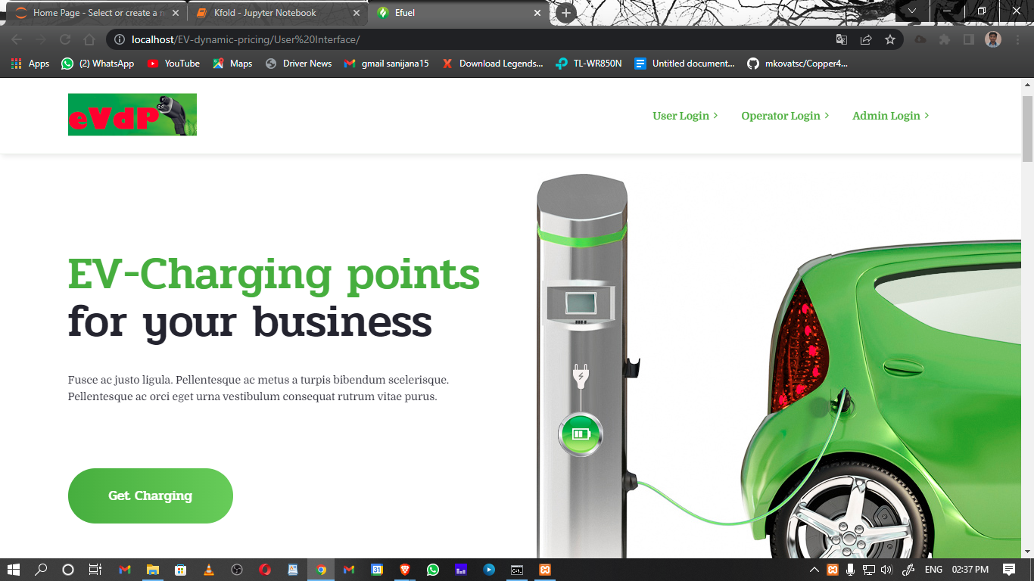The homepage has options for admin, operator and user log in.

Admin page:

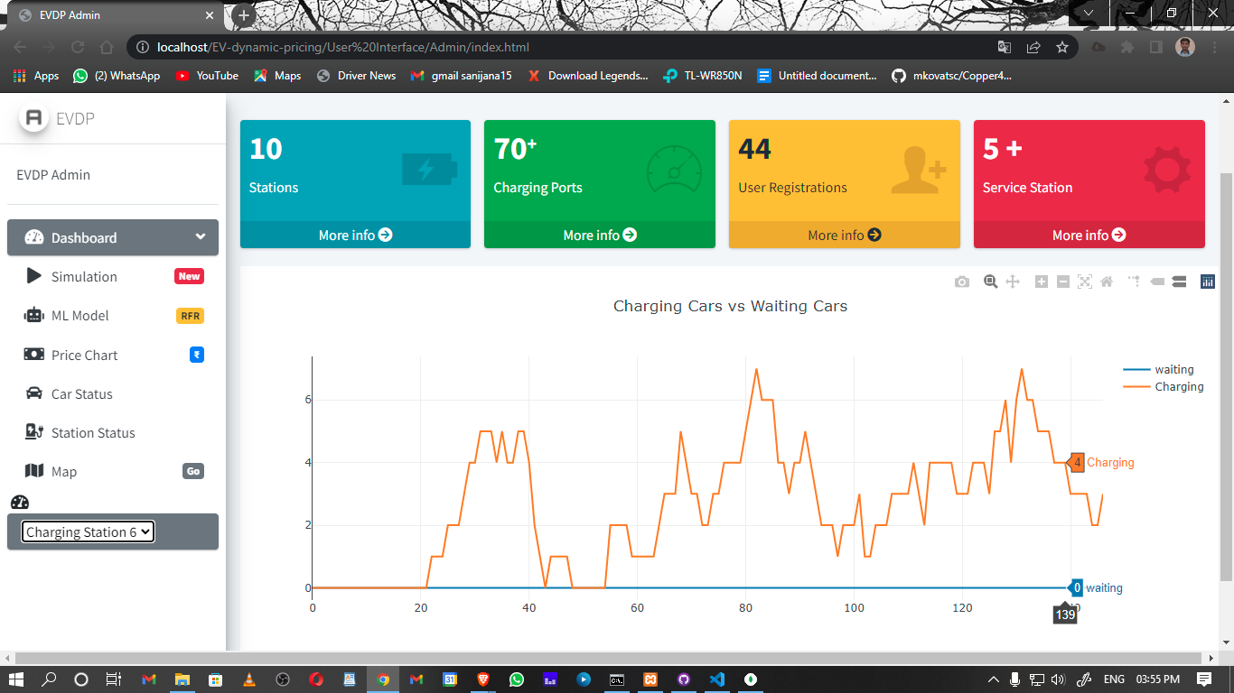After successfully logging in to the admin page admin can see the current status of any charging station, i.e., how many vehicles are charging and how many are waiting in that moment.

Admin can also check current charging price in all the charging stations in that moment.

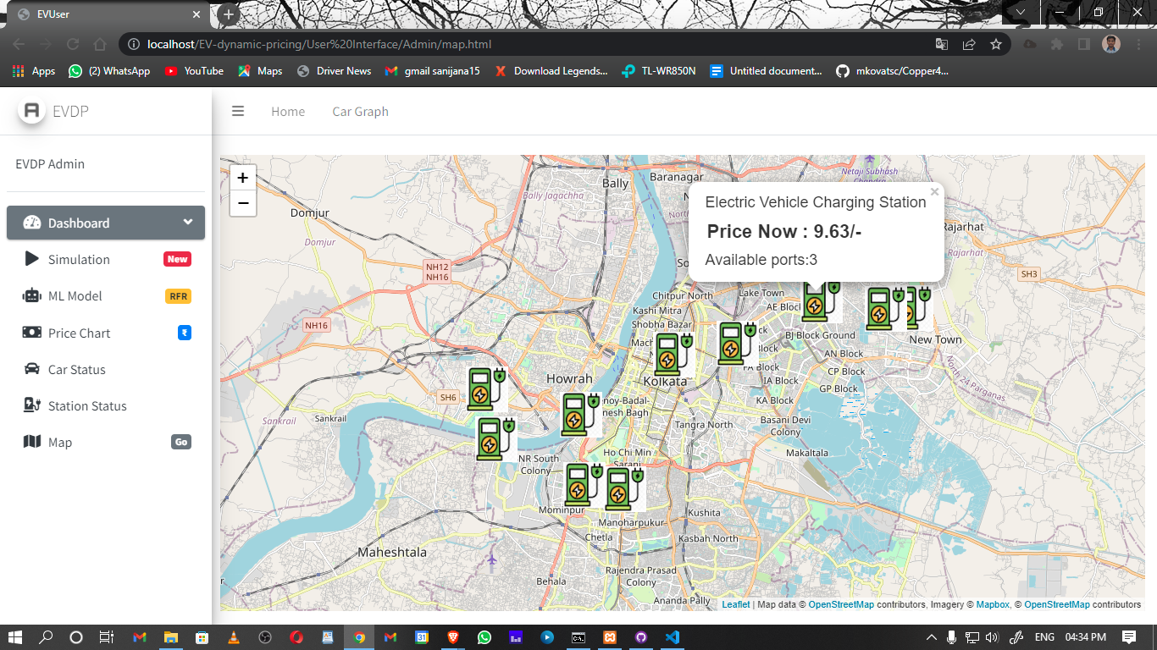

User page:

After successfully logging in, the user gets option to find nearby stations.

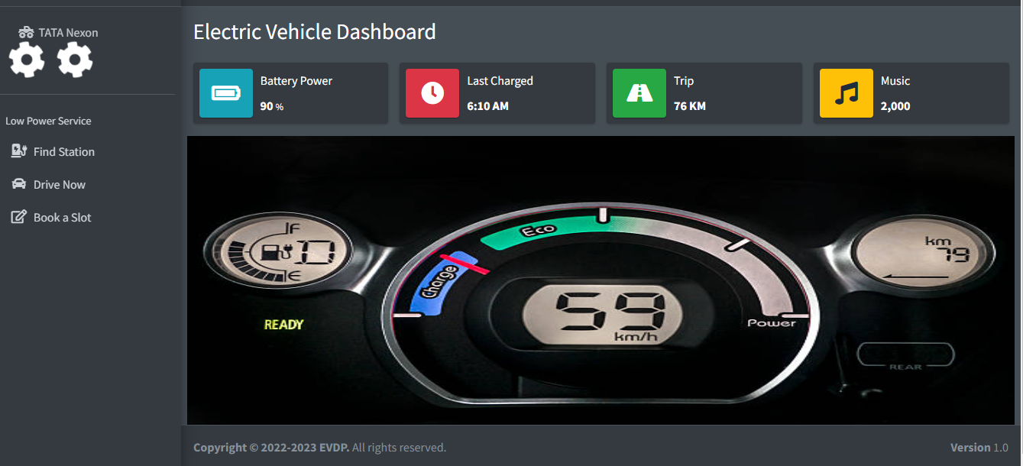

Clicking on the find station button opens the following page: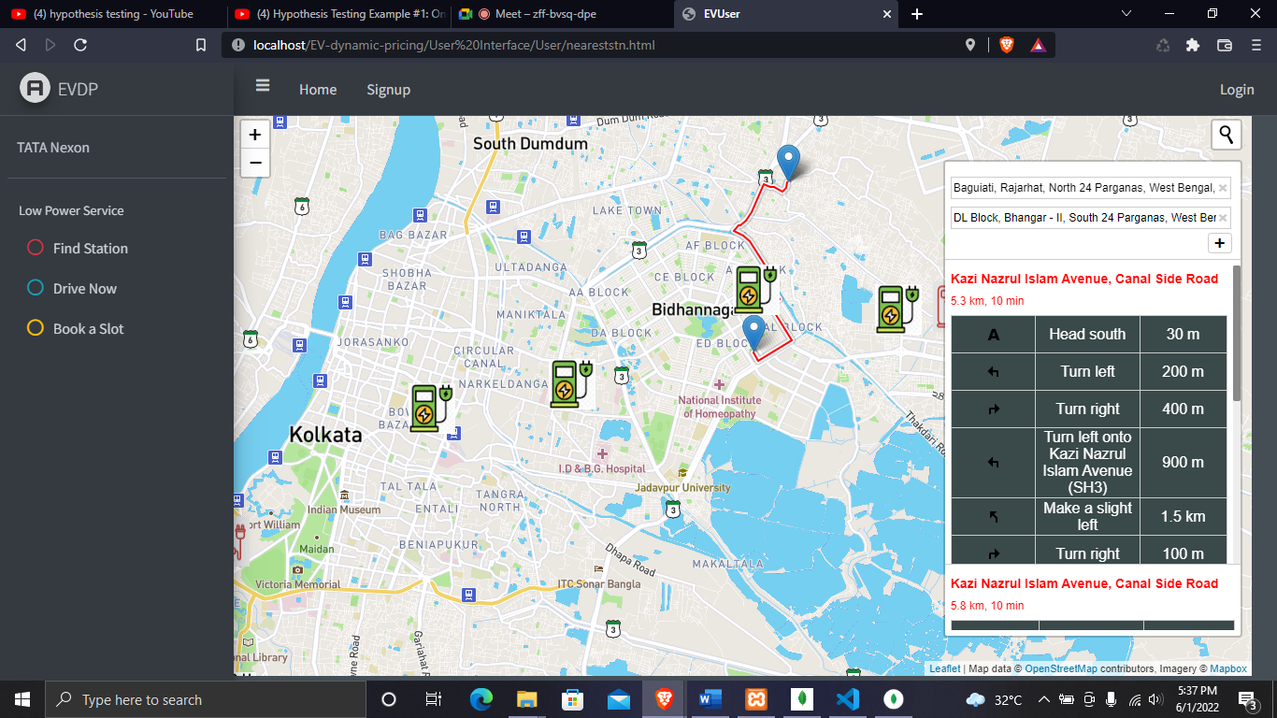

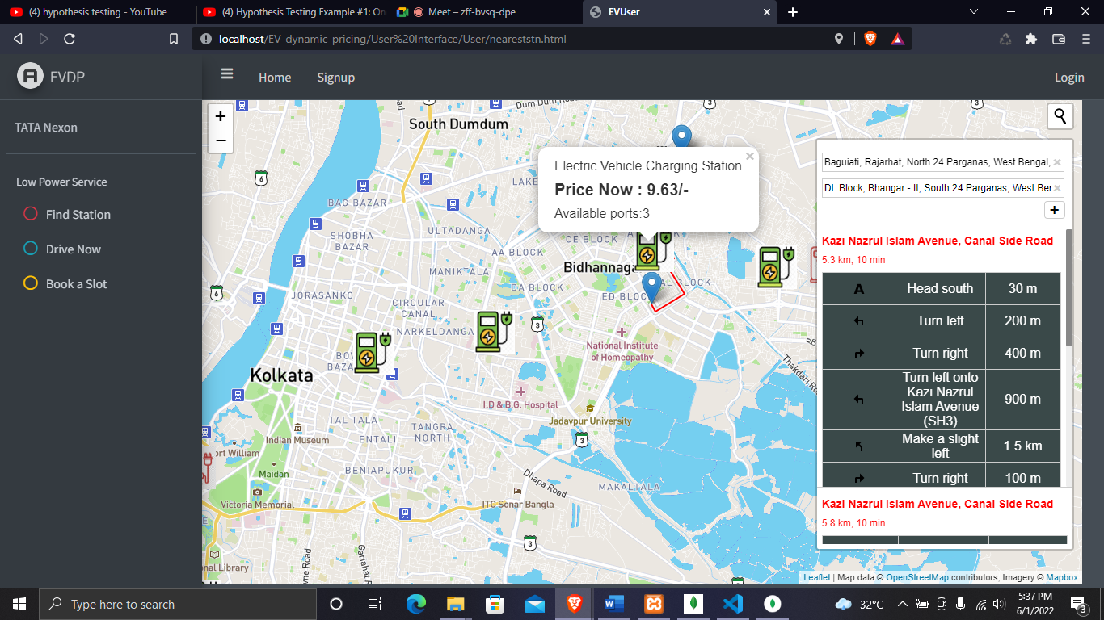After tapping on the charging station icon, the charging price is shown to the user.

Then clicking on the Drive now button automatically opens google map and helps the user to drive to the charging station selected by the user.

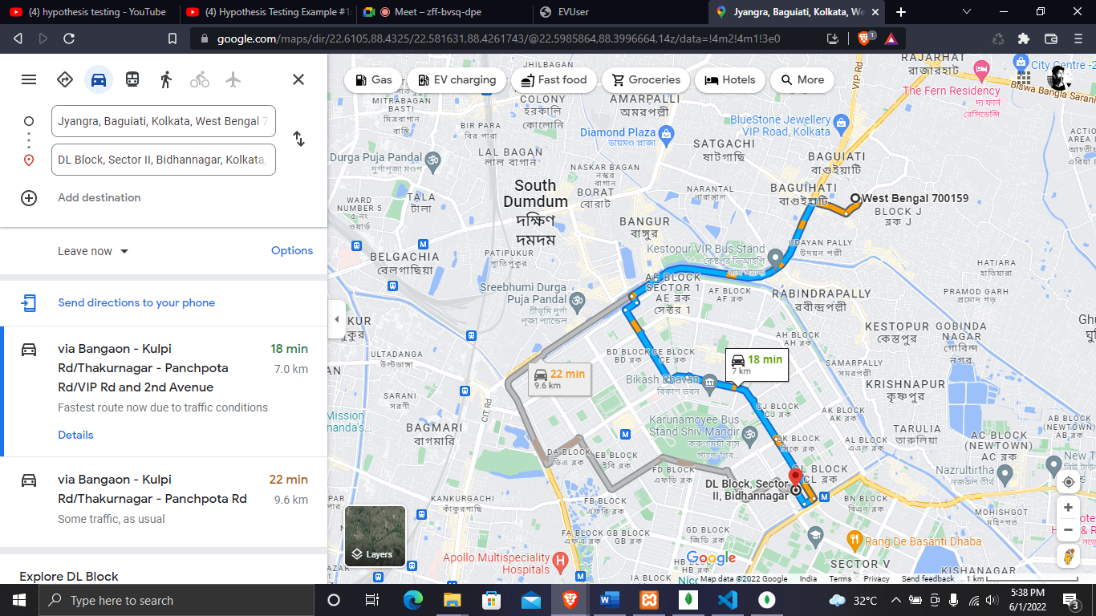

Operator :

